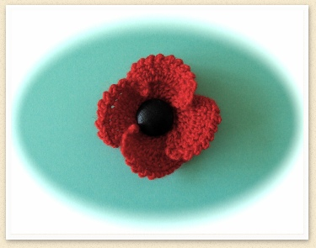

Charity Fundraiser Poppy
This pattern has been written without abbreviations
By Wendy Poole
Copyright © 2011 Wendy Poole
Oddments of red and black 4 ply yarn,
2.50mm/2.75mm crochet hook
Double knitting yarn along with a 3mm/ 3.50mm hook can be used although you will get a larger flower. (I used 3mm hook and double knitting yarn)
Make 4 chain with black yarn and join in a ring with a slip stitch.
Round 1 – Make 3 chain, then make 16 trebles into the ring. Join with a slip stitch to the 1st treble at the beginning of the round to form a ring. (16 stitches). Fasten off.
Petals (Make 4) Join red yarn on any stitch round ring.
Row 1 – Make 3 chain (this counts as the 1st treble), and 1 treble into same space, then make 2 trebles into each of the next 3 stitches. (8 stitches in total), turn.
Row 2 – Make 3 chain. Then make 1 treble into each of the next 2 stitches. Then 2 trebles into each of the next 4 stitches, then 1 treble into each of the last 2 stitches, turn
Row 3 – Make 1 chain and 1 double crochet into 1st stitch. *Now make 2 chain, 1 double crochet into next stitch*. Repeat from * to * until end of petal. Fasten off.
Re-join yarn to next stitch of round 1 and repeat Rows 1 -3 to make next petal.
Continue in this manner until 4 petals are made.
Stitch a safety pin or brooch fixing on to the back.

